**Vyasa**

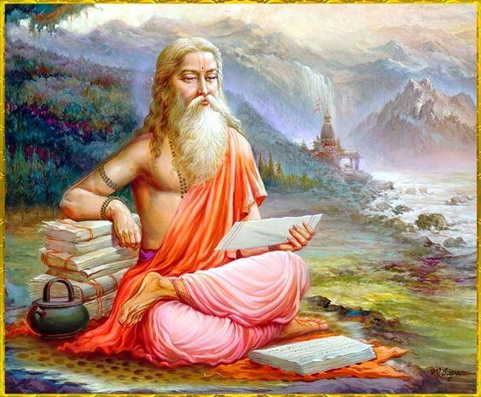

**Krishna Dvaipāyana,** also known asSage Vyasa is the author of the great Saga, Mahabharatha. He is also the author of great Vedas and Puranas. He is considered as the “Guru of Gurus”. It is believed that he is the incarnation of [Lord Vishnu](https://www.astroved.com/astropedia/en/gods/lord-vishnu), who ascended from heaven above in the Dwaparayuga to propagate Dharma and righteousness. He also had a lot of students and among them, Umantu, Vaisampayana, [Jaimini](https://www.astroved.com/astropedia/en/gods/jaimini) and Paila are noted ones. Many people believe that sage Vyasa is not just one person, but a lot of saints born time and then, whose main duty is to establish dharma.

**Birth of Sage Vyasa:**

Sage Vyasa was born to Sage Parashara and Satyavati Devi in an island on the banks of river Yamuna. He was born with a dark complexion and hence was named as Krishna. He was born on an island and was known as Dwaipayana. In his previous birth, he was born as Sage Apantaratamas, when Lord Vishnu, uttered the word “Bhu”. He is endowed with several mystical powers.

Sage Parashara was an expert in astrology and has even composed a book Parashara Hora, which is even relevant and widely used today. He was the son of Sage Vashistha. Sage Parashara’s book Parashara Smriti is one of the renowned texts. His mother Satyavati was the daughter of Dusharaj, a fisherman. Sage Parashara performed severe austerities towards [Lord Shiva](https://www.astroved.com/astropedia/en/gods/lord-shiva) and gained a lot of boons.

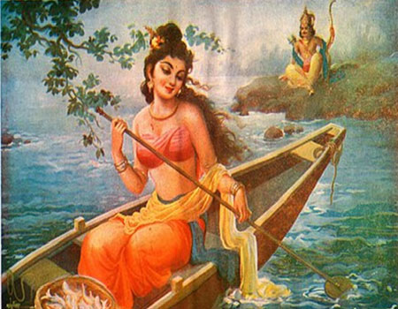It was believed that Sage Vyasa was born immediately after Sage Parashara met Satyavati Devi, while he wanted to cross a river. Sage Parashara offered a mantra as a token of his gratitude. She immedietly recited the Mantra and got a child. He immediately attained adulthood and gained his knowledge from four Kumaras, Narada and [Lord Brahma](https://www.astroved.com/astropedia/en/gods/brahma).

#### **Maharshi Vyasa as Veda Vyasa :**

Vyasa is believed to be an expansion of the God [Vishnu](https://en.wikipedia.org/wiki/Vishnu" \o "Vishnu), who came in *[Dvapara Yuga](https://en.wikipedia.org/wiki/Dvapara_Yuga" \o "Dvapara Yuga)* to make all the Vedic knowledge from oral tradition available in written form.

It is believed that the name "Veda Vyasa" (lit "compiler of the Vedas") is a title rather than an actual name. Dvaipayana was given the title as he mastered the one combined Vedic scripture and divided it into four parts — *[Rigveda](https://en.wikipedia.org/wiki/Rigveda" \o "Rigveda), [Samaveda](https://en.wikipedia.org/wiki/Samaveda), [Yajurveda](https://en.wikipedia.org/wiki/Yajurveda" \o "Yajurveda)* and *[Atharvaveda](https://en.wikipedia.org/wiki/Atharvaveda" \o "Atharvaveda)*. His spiritual career includes compiling many texts and spreading the knowledge through his disciples.

Vyasa had a son named name [Shuka](https://en.wikipedia.org/wiki/Shuka" \o "Shuka), who was his spiritual successor and heir.[[b]](https://en.wikipedia.org/wiki/Vyasa" \l "cite_note-10) As per *[Skanda Purana](https://en.wikipedia.org/wiki/Skanda_Purana" \o "Skanda Purana)*, Vyasa married Vatikā, alias Pinjalā, who was the daughter of a sage named Jābāli. It is described that Vyasa's union with her produced his heir, who repeated everything that he heard, thus receiving the name Shuka (lit. Parrot).

Other texts including the *[Devi Bhagavata Purana](https://en.wikipedia.org/wiki/Devi_Bhagavata_Purana" \o "Devi Bhagavata Purana)* also narrate the birth of Shuka but with drastic differences. Besides his heir, Vyasa had four other disciples — Paila, [Jaimini](https://en.wikipedia.org/wiki/Jaimini" \o "Jaimini), [Vaishampayana](https://en.wikipedia.org/wiki/Vaishampayana" \o "Vaishampayana) and Sumantu.[[8]](https://en.wikipedia.org/wiki/Vyasa" \l "cite_note-Bruce's_views-9) Each one of them was given the responsibility to spread one of the four Vedas. Paila was the made the incharge of *[Rigveda](https://en.wikipedia.org/wiki/Rigveda" \o "Rigveda)*, Jaimini of the *[Samaveda](https://en.wikipedia.org/wiki/Samaveda" \o "Samaveda)*, Vaishampayana of the *[Yajurveda](https://en.wikipedia.org/wiki/Yajurveda" \o "Yajurveda)* and Sumantu of *[Atharvaveda](https://en.wikipedia.org/wiki/Atharvaveda" \o "Atharvaveda)*.

Vyasa is believed to have lived on the banks of [Ganga](https://en.wikipedia.org/wiki/Ganga" \o "Ganga) in modern-day [Uttarakhand](https://en.wikipedia.org/wiki/Uttarakhand" \o "Uttarakhand). The site was also the ritual home of the sage [Vashishta](https://en.wikipedia.org/wiki/Vashishta" \o "Vashishta), along with the [Pandavas](https://en.wikipedia.org/wiki/Pandavas" \o "Pandavas), the five brothers of the [Mahabharata](https://en.wikipedia.org/wiki/Mahabharata" \o "Mahabharata).

**Contributions of Sage Vyasa :**

### The *Mahabharata*

### Vyasa dictating Ganesha writing

Vyasa is traditionally known as the chronicler of this epic and also features as an important character in Mahābhārata, Vyasa asks Ganesha to assist him in writing the text. Ganesha imposes a precondition that he would do so only if Vyasa would narrate the story without a pause. Vyasa set a counter-condition that Ganesha understands the verses first before transcribing them. Thus Vyasa narrated the entire Mahābhārata and all the [Upanishads](https://en.wikipedia.org/wiki/Upanishads" \o "Upanishads) and the 18 [Puranas](https://en.wikipedia.org/wiki/Purana" \o "Purana), while Lord Ganesha wrote.

Vyasa's *Jaya* (literally, "victory"), the core of the Mahabharata, is a dialogue between Dhritarashtra (the [Kuru](https://en.wikipedia.org/wiki/Kuru_Kingdom" \o "Kuru Kingdom) king and the father of the Kauravas, who opposed the [Pāndavas](https://en.wikipedia.org/wiki/P%C4%81ndavas" \o "Pāndavas) in the [Kurukshetra War](https://en.wikipedia.org/wiki/Kurukshetra_War" \o "Kurukshetra War)) and [Sanjaya](https://en.wikipedia.org/wiki/Sanjaya" \o "Sanjaya), his adviser and charioteer. Sanjaya narrates the particulars of the Kurukshetra War, fought in eighteen days, chronologically. Dhritarashtra at times asks questions and expresses doubts, sometimes lamenting, fearing the destruction the war would bring on his family, friends and kin.

Large and elaborate lists are given, describing hundreds of kingdoms, tribes, provinces, cities, towns, villages, rivers, mountains, forests, etc. of the (ancient) Indian subcontinent (Bhārata Varsha). Additionally, he gives descriptions of the military formations adopted by each side on each day, the death of individual heroes and the details of the war-races. Eighteen chapters of Vyasa's Jaya constitute the [Bhagavad Gita](https://en.wikipedia.org/wiki/Bhagavad_Gita" \o "Bhagavad Gita), a sacred text in [Hinduism](https://en.wikipedia.org/wiki/Hinduism" \o "Hinduism). The Jaya deals with diverse subjects, such as geography, history, warfare, religion and morality.

The final version of Vyasa's work is the [Mahābhārata](https://en.wikipedia.org/wiki/Mah%C4%81bh%C4%81rata" \o "Mahābhārata). It is structured as a narration by [Ugrasrava Sauti](https://en.wikipedia.org/wiki/Ugrasrava_Sauti" \o "Ugrasrava Sauti), a professional storyteller, to an assembly of [rishis](https://en.wikipedia.org/wiki/Rishi" \o "Rishi) who, in the [forest of Naimisha](https://en.wikipedia.org/wiki/Naimi%E1%B9%A3%C4%81ra%E1%B9%87ya_(forest)" \o "Naimiṣāraṇya (forest)), had just attended the 12-year sacrifice known as Saunaka, also known as Kulapati.

#### **Puranas**

Vyasa is also credited with the writing of the eighteen major [Purāṇas](https://en.wikipedia.org/wiki/Pur%C4%81%E1%B9%87a" \o "Purāṇa), which are works of Indian literature that cover an encyclopedic range of topics covering various scriptures. His son [Shuka](https://en.wikipedia.org/wiki/Shuka" \o "Shuka) narrates the [Bhagavata Purana](https://en.wikipedia.org/wiki/Bhagavata_Purana" \o "Bhagavata Purana) to Arjuna's grandson Parikshit.

#### **Yoga Bhashya**

The *Yoga Bhashya*, a commentary on the [Yoga Sutras](https://en.wikipedia.org/wiki/Yoga_Sutras" \o "Yoga Sutras) of [Patanjali](https://en.wikipedia.org/wiki/Patanjali" \o "Patanjali), is attributed to Vyasa.

**The Significance of Vyasa Purnima**

In ancient times, our forefathers in India, went to the forest to meditate during the four months or ‘Chaturmasa’ following Vyasa [Purnima](https://www.learnreligions.com/purnima-and-amavasya-hindu-fasts-1770182)—a particular and important day in the [Hindu calendar](https://www.learnreligions.com/hindu-festivals-calendar-1770190). On this auspicious day, Vyasa began to write his Brahma Sutras. This day is also known as [Guru Purnima](https://www.learnreligions.com/the-guru-purnima-1770188) when, according to the scriptures, Hindus should worship Vyasa and the Brahmavidya Gurus and begin the study of the Brahma Sutras and other ancient books on ‘wisdom’.

## **Brahma Sutras**

The Brahma Sutras, also known as the Vedanta Sutras is believed to have been written by Vyasa along with Badarayana. They are divided into four chapters, each chapter being subdivided again into four sections.

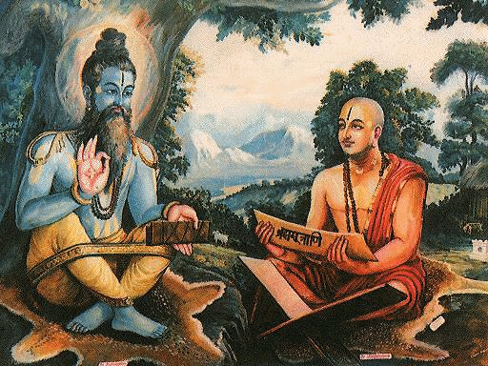

It is interesting to note that they begin and end with Sutras which read together mean "the inquiry into the real nature of Brahman has no return", pointing to "the way one reaches Immortality and no more returns to the world." About the authorship of these Sutras, tradition attributes it to Vyasa.

[Sankaracharya](https://www.learnreligions.com/shri-adi-shankaracharya-bio-1770331) refers to Vyasa as the author of the Gita and the Mahabharata, and to Badarayana as the author of the Brahma Sutras. His followers - Vachaspathi, Anandagiri, and others - identify the two as one and the same person, while Ramanuja and others attribute the authorship of all three to Vyasa himself.

##### **Vyasa Contribution to astronomy and geography**

Veda Vyasa not only focused on the work on [Mahabharatha](https://en.wikipedia.org/wiki/Mahabharata)but also on astronomical and geographical knowledge. He interested in those subjects because his father Parasara also an astronomer, who had written astronomical texts like Parasara Samhita. Probably Vyasa got interested in astronomy and may guide by his father Parasara. He observed the positions of stars, planets and recorded the observations and the crucial incidents of Mahabharata. Those same observations helped the present day historians to date Kuru war. Vyasa also narrated the geography of ancient India, about several kingdoms, provinces, lakes, rivers, and mountains with their full names.

## **The Everlasting Influence of Vyasa**

Vyasa is considered by Hindus as Chiranjivi or immortal, one who is still living and walking the earth for the well-being of his devotees. It is said that he appears to the true and the faithful and that Adi Sankaracharya had his darshan as did many others as well. Vyasa’s life is a unique example of one born for the dissemination of spiritual knowledge. His writings inspire us and the whole world even to this day in innumerable ways. To honor the great Saint, a temple has been built in Kalpi, Orai, Uttar Pradesh. This temple is known as Shri Bal Vyas Mandir. The contributions of Sage Vyasa is amazing and is unfathomable. He has set the path for humans to reach immortality, and the soul reaches the greatest divine state, where there is no return.